Yaron Granot  Concept Artist, Illustrator, 2D Sprites & VFX, Visual Development  About Me  I’m pursuing a concept-art, visual development, illustration or game-design (2D sprites & VFX) position in the entertainment industry. I want to be a part of a skilled designers team from which I further extend my skills-set and knowledge as an artist. | +972 50-5708006  Tel Aviv, Israel
Employee designer, illustrator and video editor  - 2009-2011 – Graphic designer at Briefcam, video synopsis company.  - 2012 – Concept artist and 2D designer at Space Cowboys Studio, game dev studio.  - 2014-2015 – Graphic designer, UI designer, illustrator and video editor at Overwolf, in-game pc appstore.  Freelance concept-artist and illustrator  - 2003-2005 – Pixel-artist\animator for Gamebit and OneManBand, mobile gaming.  - 2013 – Key illustration for Mobixon, augmented reality game project.  - 2015 – UI designer and illustrator for NC Arts, augmented reality game project.  - 2015 – Helmets concepts for Yashinski, Will.I.Am music clip. | 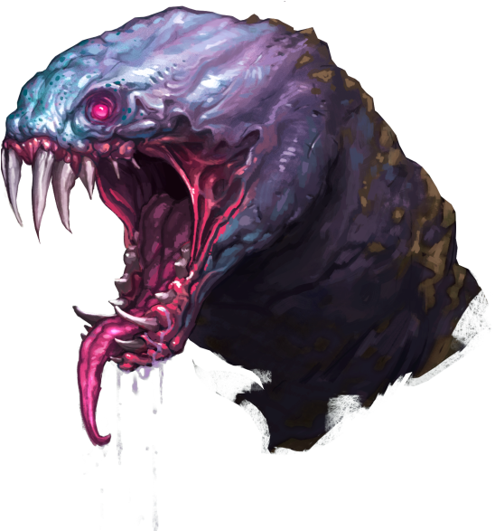  Experience
- PHOTOSHOP (2d concept art, illustration, visual development and design)  - ILLUSTRATOR (2d UI, logo design, web design)  - AFTER EFFECTS (2d VFX, sprites animations)  - PREMIERE (video editing)  - TRADITIONAL (sketching and painting) | Proficiency
- People person, team player, love working with people in a fun and productive atmosphere.  - Self taught artist.  - Full control over all standard Windows applications (Office, internet browsers, etc.…).  - Fluent Hebrew and English.  Military Service  Three years of service as a tank commander in the Israeli Armored Corps (2005-2008) | Other Skills & Occupations

